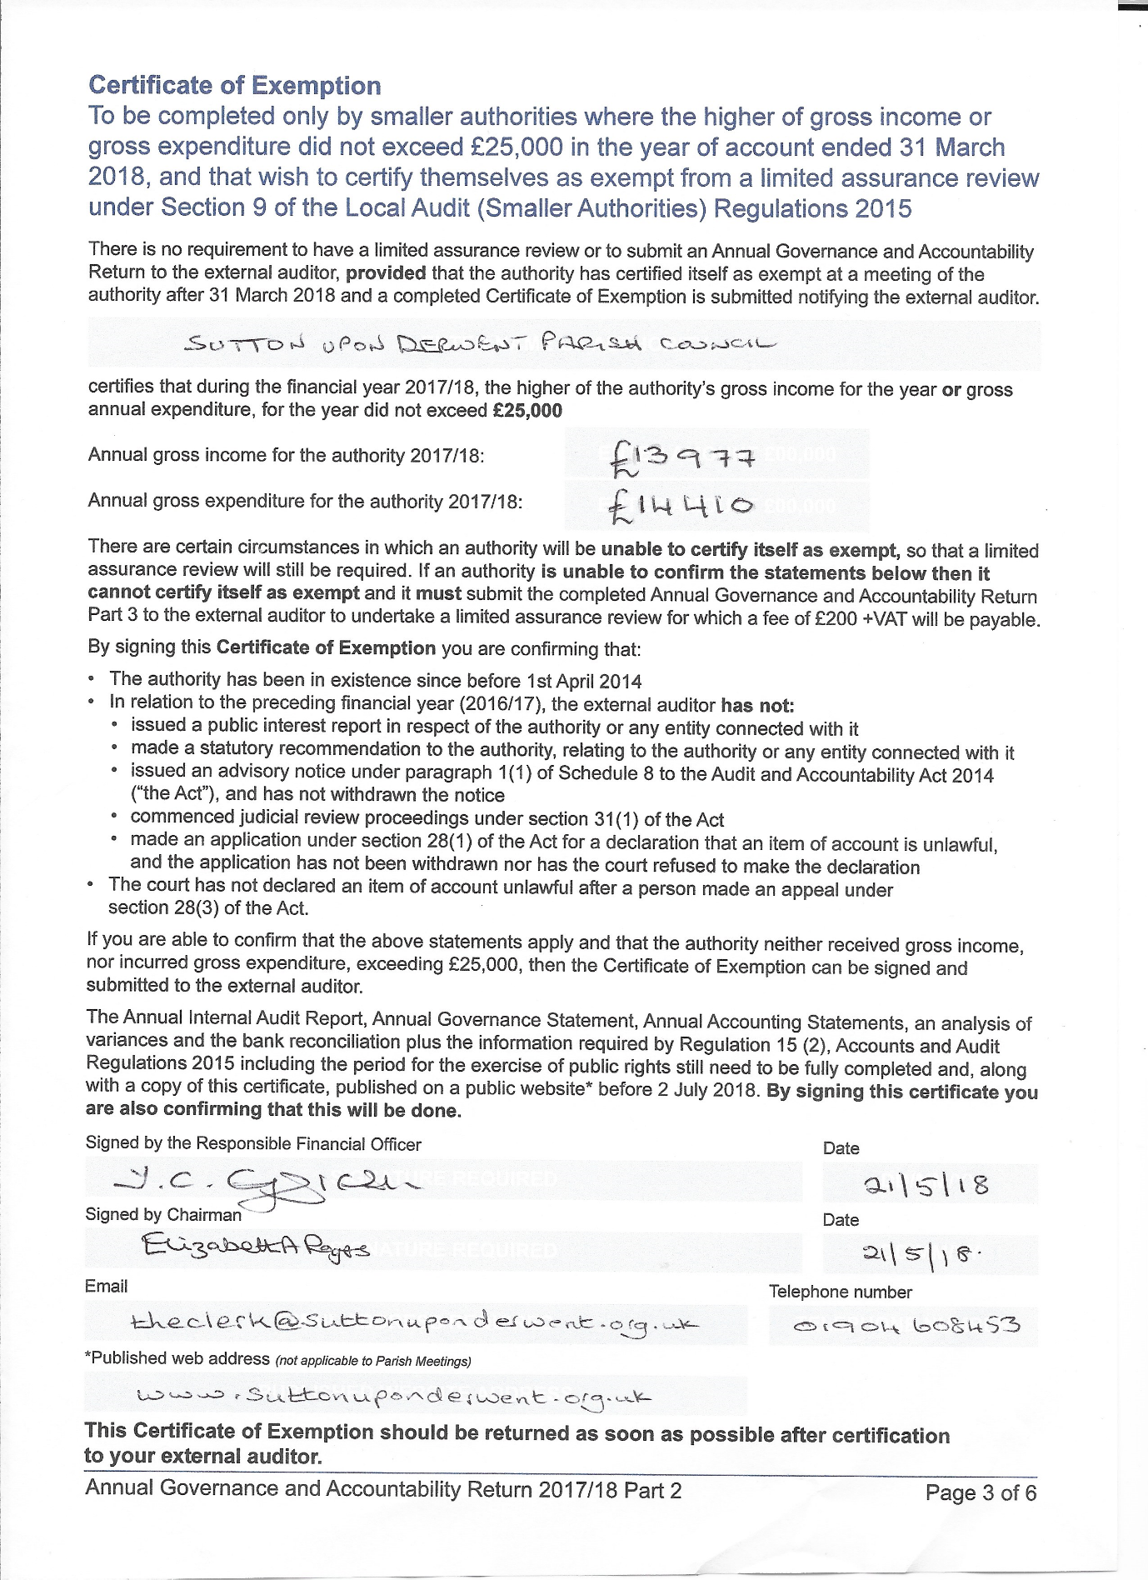

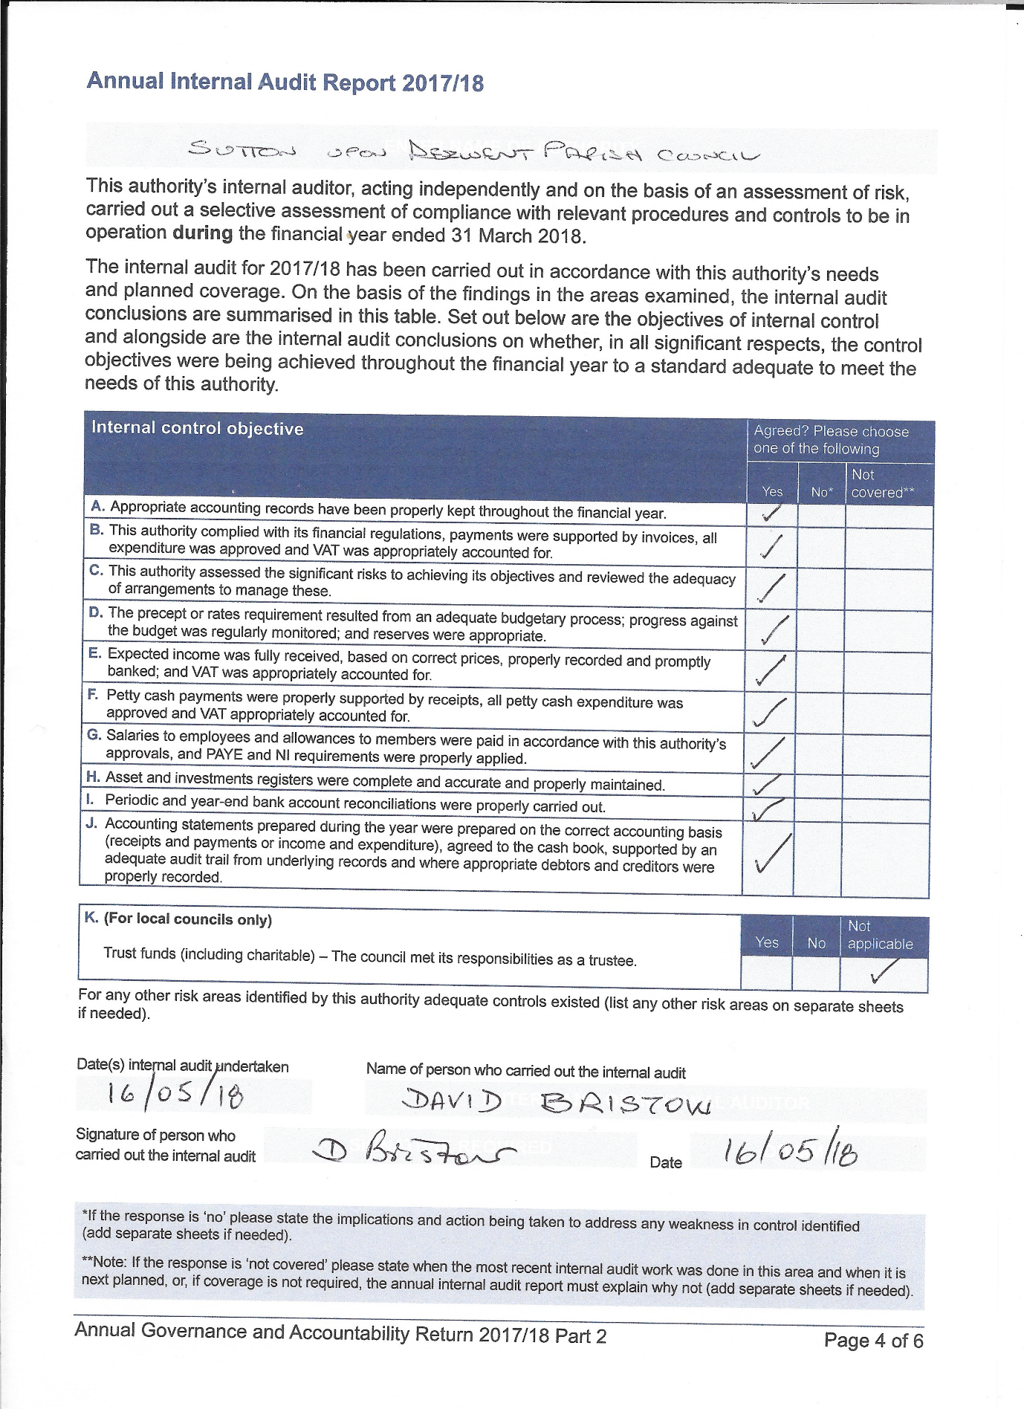

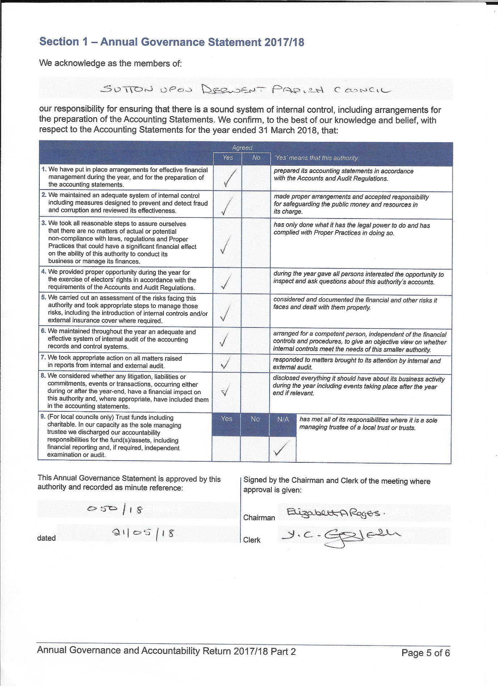

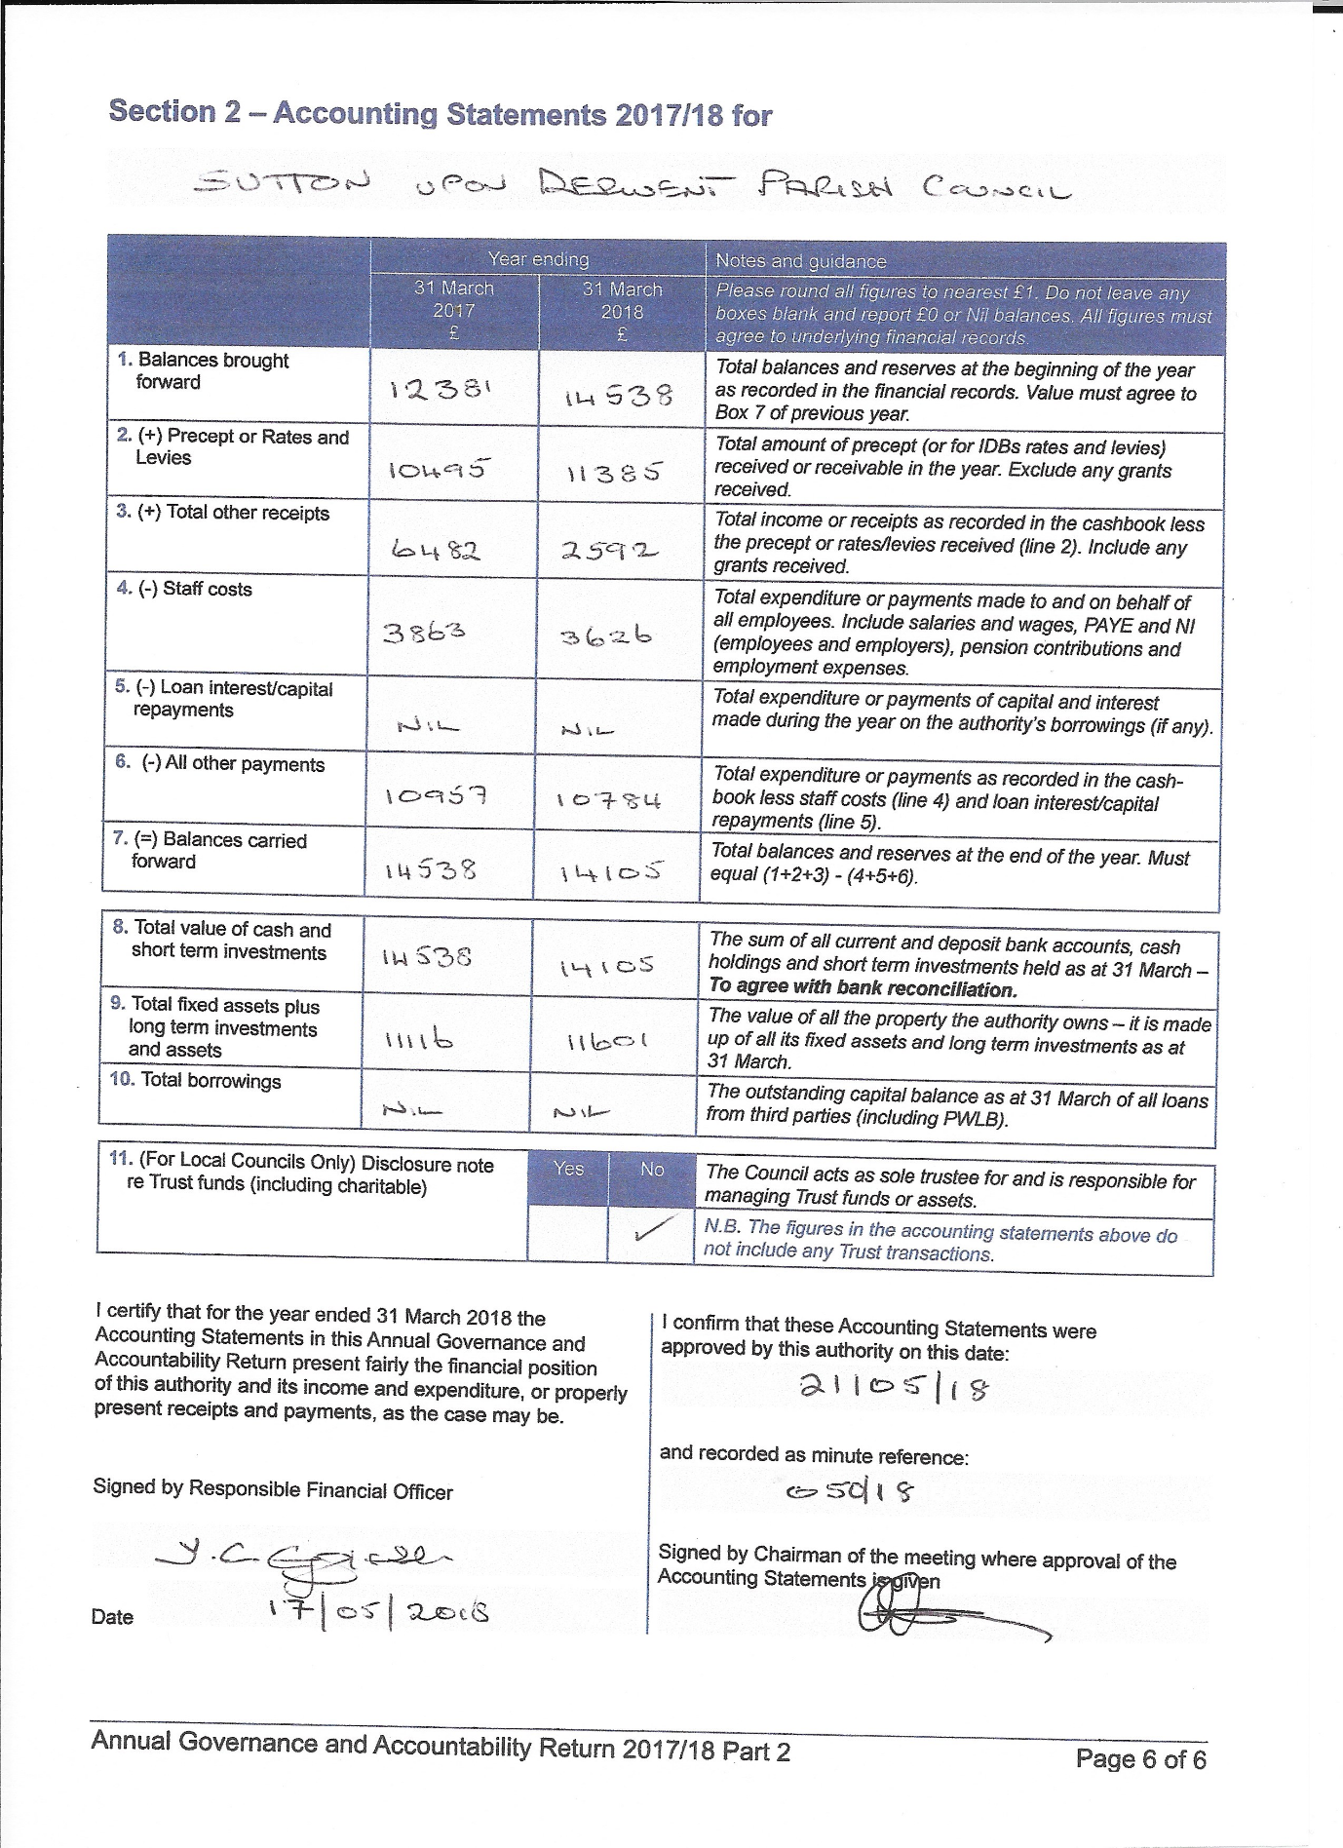

Annual Return for the year ended 31 March 2018

Explanation of Significant Variances arising in the year ending amounts of Section 2

Box | y/e 2017 | y/e 2018 | Difference | 15% | Explanation
2. Precept | 10495 | 11385 | +890 | +8.5% | None Req’d
3. Total Other Receipts | 6482 | 2592 | -3890 | -60% | 1.
4. Staff Costs | 3863 | 3626 | -237 | +6% | None Req’d
5. Interest/Repayments | 0 | 0 | 0
6. All Other Payments | 10957 | 10784 | -173 | -1.5% | None Req’d
9. Total Fixed Assets | 11117 | 11601 | +484 | +4.4% | None Req’d
(Please note all values are rounded to the nearest £)

Explanations:

1. Increase in revenue received from Fireworks Display +£245
Increase in grant received from Government Transparency Fund +£295
Contribution from Tennis Club for cutting grass +£100

Decrease in grant received from ERYC for cutting grass of parish public footpaths -£48

NB One-off grant of -£2000 received in 16/17 from ERYC
Donation in 16/17 from Village Hall for purchase of defibrillator -£1270
Difference in VAT claimed not yet received -£1135
All staff costs covered under ‘Staff Costs’ -£79

BANK RECONCILLIATION
SUTTON UPON DERWENT PARISH COUNCIL

Financial Year ending 31st March 2018
Prepared by Y C Eggleston (Clerk & Responsible Financial Officer) 23rd April 2018

Balance as per bank statements as at 31st March 2018

Community Account 10665.33
Deposit Account 3589.72
14255.05

Less - unpresented cheques

101307 150.00
--------
150.00 150.00
_____________ _________
Net Balances as at 31st March 2018 14105.05
==================

CASH BOOK

Opening Balance 1st April 2017 14538.34
Plus - receipts for year 13976.88
__________________
28515.22
Less payments for the year 14410.17
__________________
Closing Balance as per Cash Book 14105.05
==================

